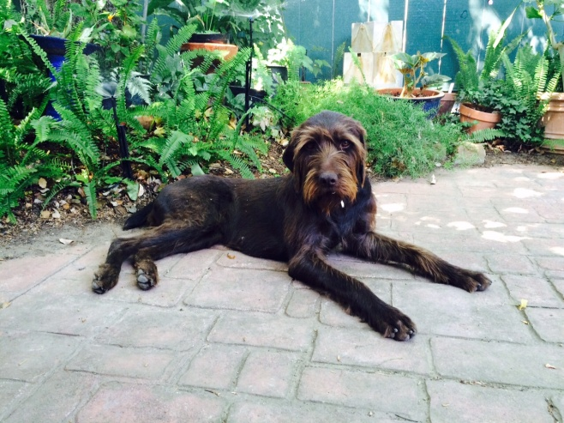
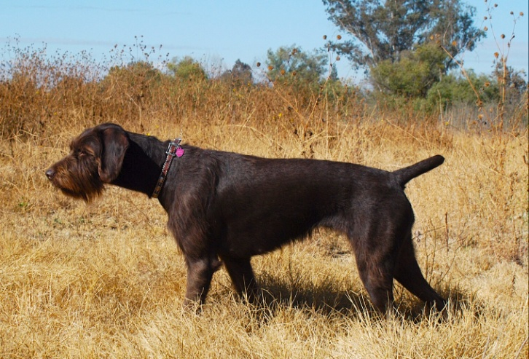
Reservations now being taken for puppies from Wherry’s “C” Litter - available in May 2018
** Pups will be FCI registered and come with VPP Ahnentafels
Contact Andrew Hewett andy@wherrygundogs.com
(559)203-0501
Sire: Zito vom Orsoyer Land, Pudelpointer # 15074
Zito is a proven VJP & HZP male that has produced outstanding pups
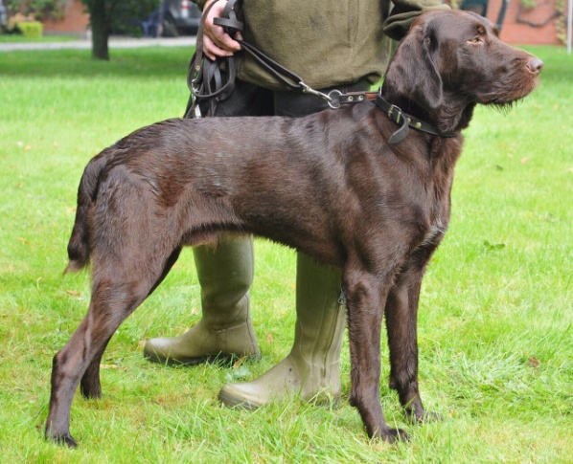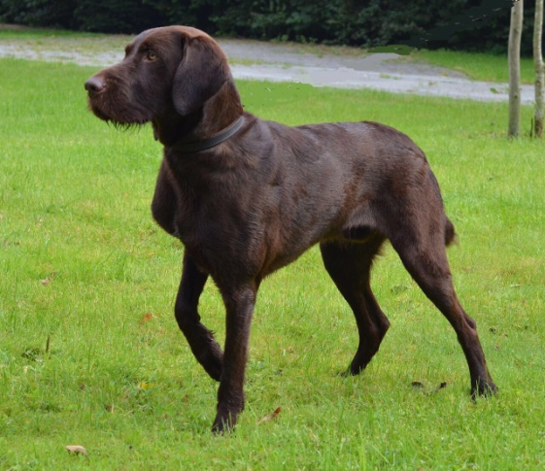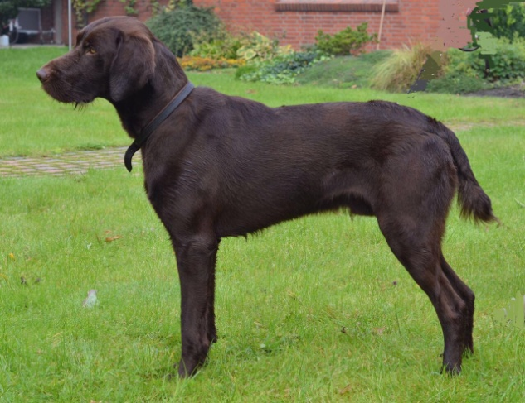
Dam: Laura vom Fürstenberg, Pudelpointer # 14984
Laura “Lucy” is also a proven, very athletic hunting dog who has delivered impressive pups in our “B” litter. She has a sweet temperament balanced with her strong desire
